14.62: To save some intermediate calculation, let the density, mass and volume of the life preserver be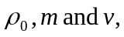 and the same quantities for the person be 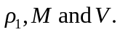 Then, equating the buoyant force and the weight, and dividing out the common factor of 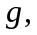

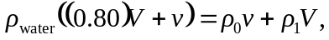

Eliminating  in favor of 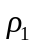 and 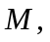 and eliminating m in favor of 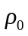 and 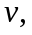
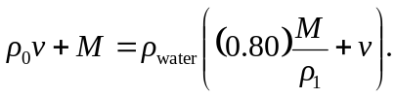
Solving for 